Gravity Optimizer: A Physical Approach to Optimization in Deep Learning

D. Bahrami, S. Pouriyan Zadeh, Member, IEEE

**Abstract**—These instructions give you guidelines for preparing papers for IEEE Computer Society Transactions. Use this document as a template if you are using Microsoft Word 6.0 or later. Otherwise, use this document as an instruction set. Please note that use of IEEE Computer Society templates is meant to assist authors in correctly formatting manuscripts for final submission and does not guarantee how the final paper will be formatted by IEEE Computer Society staff. This template may be used for initial submissions; however, please consult the author submission guidelines for formatting instructions as most journals prefer single column format for peer review. An abstract should be 100 to 200 words for regular papers, no more than 50 words for short papers and comments, and should clearly state the nature and significance of the paper. Abstracts *must not* include mathematical expressions or bibliographic references. Please note that abstracts are formatted as left justified in our editing template (as shown here).

**Index Terms**— Optimization, I.5.1.d Neural nets

xxxx-xxxx/0x/$xx.00 © 200x IEEE Published by the IEEE Computer Society

————————————————

1. F.A. Author is with the National Institute of Standards and Technology, Boulder, CO 80305. E-mail: author@ boulder.nist.gov.
2. S.B. Author Jr. is with the Department of Physics, Colorado State University, Fort Collins, CO 80523. E-mail: author@colostate.edu.

*Please note that all acknowledgments should be placed at the end of the paper, before the bibliography (****note that corresponding authorship is not noted in affiliation box, but in acknowledgment section****).*

—————————— ◆ ——————————

# 1 Introduction

T

HE question of choosing an adequate optimizer for a deep learning problem is not answered yet. Instead there are ways like empirical comparing [1]–[3] or benchmarking [4] which help to find better configurations for optimization.

The most common optimization techniques in deep learning are SGD (Stochastic Gradient Descent)[5], RMS Prop[6], and Adam[7]. Table 1 shows the most common standard optimization techniques or optimizers in chronicle order.

TABLE 1  
the most common standard optimizers in deep learning

|  |  |
| --- | --- |
| Year Published | Optimization technique |
| 1951 [5] | SGD |
| 1964 [8] | SGD with momentum |
| 2011 [9] | AdaGrad |
| 2012 [10] | AdaDelta |
| 2012 [6] | RMSProp |
| 2013 [11] | SGD with Nesterov momentum |
| 2015 [7] | Adam |
| 2015 [7] | Adamax |
| 2016 [12] | Nadam |
| 2018 [13] | AMSGrad |

To insert images in Word*,* position the cursor at the insertion point and either use Insert | Picture | From File or copy the image to the Windows clipboard and then Edit | Paste Special | Picture (with “Float over text” unchecked).

IEEE Computer Society staff will edit and complete the final formatting of your paper.

# 2 Procedure for Paper Submission

## 2.1 Review Stage

Detailed submission guidelines can be found on the author resources Web pages. Author resource guidelines are specific to each journal, so please be sure to refer to the correct journal when seeking information. All authors are responsible for understanding these guidelines before submitting their manuscript. For further information on both submission guidelines, authors are strongly encouraged to refer to <http://www.computer.org/portal/web/peerreviewjournals/author>.

## 2.2 Final Stage

For papers accepted for publication, it is essential that the electronic version of the manuscript and artwork match the hardcopy exactly! The quality and accuracy of the content of the electronic material submitted is crucial since the content is not recreated, but rather converted into the final published version.

All papers in IEEE Computer Society Transactions are edited electronically. A final submission materials check list, transmission and compression information, and general publication materials can be found at: <http://www.computer.org/portal/web/peerreviewjournals/author>.

## 2.3 Figures

All tables and figures will be processed as images. You will have the greatest control over the appearance of your figures if you are able to prepare electronic image files. Save them to a file in PostScript (PS) or Encapsulated PostScript (EPS) formats. Use a separate file for each image. File names should be of the form “fig1.ps” or “fig2.eps.”

For more information on how to format your figure or table files for final submission, please go to <http://www.computer.org/portal/web/peerreviewjournals/author#figures> and [View transactions art_guide.pdf (PDF, 4.69MB)](http://www.computer.org/cms/Computer.org/Journal%20templates/transactions_art_guide.pdf).

## Copyright Form

An IEEE Computer Society copyright form must accompany your final submission. You can get a .pdf, .html, or .doc version at <http://computer.org/copyright.htm>. Authors are responsible for obtaining any security clearances.

For any questions about initial or final submission requirements, please contact one of our staff members. Contact information can be found at: <http://www.computer.org/portal/web/volunteercenter/staff>.

# 3 Benchmark

In this section, we are going to compare Gravity optimizer with other common standard optimizers shown in Table 1. In the following, first, the specifications of the hardware that we used for training are given. Then the framework we used to implement the model, the datasets used for training, and finally, the architectures chosen based on hardware specifications are introduced. If you want to skip reading the details, a summary of this information is given in Table 4. In the last part, the obtained results from Gravity optimizer are compared to the reported results from other papers that have used the same architectures we used to teach the same datasets we used. If results are not reported by other papers, the tests have been performed by us.

We used Google Colab (colab.research.google.com) as hardware because we couldn’t afford GPU for training deep neural network models on it and testing our idea. We used Tensorflow’s high-level API, Keras, as a framework to build the model in the Python language. The python implementation code can be found in this repository: github.com/dariush-bahrami/gravity.optimizer On the other hand, with Google Colab and TensorFlow, we were given the chance to use TPUs (Tensor Processing Unit), Google’s custom-developed technology used to accelerate machine learning workloads[].

We used the following standard datasets to evaluate the performance of the Gravity optimizer: MNIST, Fashion-MNIST, CIFAR-10, CIFAR-100 (Coarse), and CIFAR-100 (Fine). The MNIST database of handwritten digits is a subset of a larger set available from NIST. The digits have been size-normalized and centered in a fixed-size image []. The Fashion-MNIST is a dataset containing images of 10 classes. The 10 different classes are T-shirt, Trouser, Pullover, Dress, Coat, Sandal, Shirt, Sneaker, Bag, and Ankle boot[]. CIFAR-10 is a subset of the 80 million tiny images dataset in 10 classes. The 10 different classes represent airplanes, cars, birds, cats, deer, dogs, frogs, horses, ships, and trucks []. CIFAR-100 is just like the CIFAR-10, except it has 100 classes containing 600 images each. The 100 classes in the CIFAR-100 are grouped into 20 superclasses. Each image comes with a "fine" label (the class to which it belongs) and a "coarse" label (the superclass to which it belongs). We trained the “fine” and “coarse” datasets separately because they have two distinct labels that classify two different types of classification; “coarse” is more general and “fine” is more specific[]. Table 2 summarizes the detailed information of the datasets used.

TABLE 2  
detailed information of datasets used for benchmark

|  |  |  |  |  |  |
| --- | --- | --- | --- | --- | --- |
| Dataset | Train # | Test # | Class # | Shape | Image per class |
| MNIST | 60 K | 10 K | 10 | 28x28x1 | 6 K |
| Fashion-MNIST | 60 K | 10 K | 10 | 28x28x1 | 6 K |
| CIFAR-10 | 50 K | 10 K | 10 | 32x32x3 | 5 K |
| CIFAR-100 (coarse) | 50 K | 10 K | 20 | 32x32x3 | 2.5 K |
| CIFAR-100 (fine) | 50 K | 10 K | 100 | 32x32x3 | 500 |

We used **VGG16** and **VGG19** with the exact specifications reported in their paper[]. VGG16 has about 34M and VGG19 has about 39M parameters[]. Although architectures such as ResNet50[] and EfficientNet[] have 23M and 4M parameters respectively, and they are as easy to implement as VGGNet in Keras, they showed so much slower training speed when implemented in Google Colab that (their model summaies for input shape of 32x32x3 and 10 classes are in Gravity github repository). Another reason why we have chosen VGG architecture over other architectures is that it doesn’t use any techniques to prevent overfitting. We want to minimize the impact of parameters such as Dropout[], Early Stopping[], L2 Regulation[], and Batch Normalization[] other than the optimizer on optimization. Finally, we monitor the loss and accuracy changes for the training and validation datasets for a constant number of epochs so that we can compare the performance of the Gravity optimizer to common standard optimizers listed in Table 1 with the same dataset and architecture without the impact of overfitting prevention techniques. Table 3 summarizes the models used in this paper.

In Section 2, we talked about how to find the best values for the alpha, beta, and m hyperparameters in the gravity optimizer and why. Then, by performing various runs, we obtained and reported the best values. In this section, we used those suggested values for the benchmark. The remarkable thing about gravity optimizer is that in all the benchmarks we did (in all five datasets and two architectures used) the same values were considered for the hyperparameter and there was no need to change the hyperparameter to get a better result.

Table 3  
VGG model summary used in the paper

|  |  |  |  |  |  |
| --- | --- | --- | --- | --- | --- |
| **VGG16** | | | **VGG19** | | |
| **Layer Type** | **Output Shape** | **Parameters #** | **Layer Type** | **Output Shape** | **Parameters #** |
| **Convolution Part** | | | **Convolution Part** | | |
| Input Layer | 32, 32, 3 | 0 | Input Layer | 32, 32, 3 | 0 |
| Conv2D | 32, 32, 64 | 1,792 | Conv2D | 32, 32, 64 | 1,792 |
| Conv2D | 32, 32, 64 | 36,928 | Conv2D | 32, 32, 64 | 36,928 |
| MaxPooling2D | 16, 16, 64 | 0 | MaxPooling2D | 16, 16, 64 | 0 |
| Conv2D | 16, 16, 128 | 73,856 | Conv2D | 16, 16, 128 | 73,856 |
| Conv2D | 16, 16, 128 | 147,584 | Conv2D | 16, 16, 128 | 147,584 |
| MaxPooling2D | 8, 8, 128 | 0 | MaxPooling2D | 8, 8, 128 | 0 |
| Conv2D | 8, 8, 256 | 295,168 | Conv2D | 8, 8, 256 | 295,168 |
| Conv2D | 8, 8, 256 | 590,080 | Conv2D | 8, 8, 256 | 590,080 |
| Conv2D | 8, 8, 256 | 590,080 | Conv2D | 8, 8, 256 | 590,080 |
| MaxPooling2D | 4, 4, 256 | 0 | Conv2D | 8, 8, 256 | 590,080 |
| Conv2D | 4, 4, 512 | 1,180,160 | MaxPooling2D | 4, 4, 256 | 0 |
| Conv2D | 4, 4, 512 | 2,359,808 | Conv2D | 4, 4, 512 | 1,180,160 |
| Conv2D | 4, 4, 512 | 2,359,808 | Conv2D | 4, 4, 512 | 2,359,808 |
| MaxPooling2D | 2, 2, 512 | 0 | Conv2D | 4, 4, 512 | 2,359,808 |
| Conv2D | 2, 2, 512 | 2,359,808 | Conv2D | 4, 4, 512 | 2,359,808 |
| Conv2D | 2, 2, 512 | 2,359,808 | MaxPooling2D | 2, 2, 512 | 0 |
| Conv2D | 2, 2, 512 | 2,359,808 | Conv2D | 2, 2, 512 | 2,359,808 |
| MaxPooling2D | 1, 1, 512 | 0 | Conv2D | 2, 2, 512 | 2,359,808 |
| **Dense Part** | | | Conv2D | 2, 2, 512 | 2,359,808 |
| Flatten | 512 | 0 | Conv2D | 2, 2, 512 | 2,359,808 |
| Dense | 4096 | 2,101,248 | MaxPooling2D | 1, 1, 512 | 0 |
| Dense | 4096 | 16,781,312 | **Dense Part** | | |
| Dense | 10 | 40,970 | Flatten | 512 | 0 |
|  |  |  | Dense | 4096 | 2,101,248 |
|  |  |  | Dense | 4096 | 16,781,312 |
|  |  |  | Dense | 10 | 40,970 |
| **Total Parametrs = 33,638,218** | | | **Total Parametrs = 38,947,914** | | |

Our recommended value for learning rate, Alpha, and Beta is 0.1, 0.01, 0.9 respectively. We also set these values as default for Gravity optimizer in python implementation. In the next section, the results obtained from the training of five standard datasets with Gravity optimizers and two other standard and widely used optimizers (RMSProp and Adam) are compared. All trainings here are done with batch size of 128 and for 100 epochs.

# 4 Citations

IEEE Computer Society style is to note citations in individual brackets, followed by a comma, e.g. “[1], [5]” (as opposed to the more common “[1, 5]” form.) Citation ranges should be formatted as follows: [1], [2], [3], [4] (as opposed to [1]-[4], which is not IEEE Computer Society style). When citing a section in a book, please give the relevant page numbers [2]. In sentences, refer simply to the reference number, as in [3]. Do not use “Ref. [3]” or “reference [3]” At the beginning of a sentence use the author names instead of “Reference [3],” e.g., “Smith and Smith [3] show ... .” Please note that references will be formatted by IEEE Computer Society production staff in the same order provided by the author.

# 5 Equations

If you are using Word, use the MathType add-on (<http://www.mathtype.com>) for equations in your paper (Insert | Object | Create New | Microsoft Equation or MathType Equation). “Float over text” should not be selected.

For display equations as seen below, number equations consecutively with equation numbers in parentheses flush with the right margin, as in (1). First, use the equation editor to create the equation. Then, select the “Equation” markup style. Press the tab key and write the equation number in parentheses. To make your equations more compact, you may use the solidus ( / ), the exp function, or appropriate exponents. Use parentheses to avoid ambiguities in denominators. Punctuate equations when they are part of a sentence, as in

 (1)

Be sure that the symbols in your equation have been defined before the equation appears or immediately following. Italicize symbols (*T* might refer to temperature, but T is the unit tesla). Per IEEE Computer Society, please refer to “(1),” not “Eq. (1)” or “equation (1),” except at the beginning of a sentence: “Equation (1) shows ... .” Also see *The Handbook of Writing for the Mathematical Sciences*, 1993. Published by the Society for Industrial and Applied Mathematics, this handbook provides some helpful information about math typography and other stylistic matters. For further information about typesetting mathematical equations, please visit the IEEE Computer Society style guide: <http://www.computer.org/portal/web/publications/style_math>.

Please note that math equations might need to be reformatted from the original submission for page layout reasons. This includes the possibility that some in-line equations will be made display equations to create better flow in a paragraph. If display equations do not fit in the two-column format, they will also be reformatted. Authors are strongly encouraged to ensure that equations fit in the given column width.

# 6 Helpful Hints

## 6.1 Figures and Tables

Because IEEE Computer Society staff will do the final formatting of your paper, some figures may have to be moved from where they appeared in the original submission. Figures and tables should be sized as they are to appear in print. Figures or tables not correctly sized will be returned to the author for reformatting.

Detailed information about the creation and submission of images for articles can be found at <http://www.computer.org/portal/web/peerreviewjournals/author#figures> where you can [View transactions art_guide.pdf (PDF, 4.69MB)](http://www.computer.org/cms/Computer.org/Journal%20templates/transactions_art_guide.pdf) . We strongly encourage authors to carefully review the material posted here to avoid problems with incorrect files or poorly formatted graphics.

Place figure captions below the figures; place table titles above the tables. Figure captions appear as left justified. Table captions are restricted to one sentence and are formatted as title case. Any additional sentence in a table caption will be formatted as a footnote below the table (see Table 1 in this document). If your figure has two parts, include the labels “(a)” and “(b)” as part of the artwork. Please verify that the figures and tables you mention in the text actually exist. Figures and tables should be called out in sequential order, as this is how they will be placed in your paper. For example, avoid referring to figure “8” in the first paragraph of the article unless figure 8 will again be referred to after the reference to figure 7. **Please do not include figure captions as part of the figure. Do not put captions in “text boxes” linked to the figures. Do not put borders around the outside of your figures.** Per IEEE Computer Society, please use the abbreviation “Fig.” even at the beginning of a sentence. Do not abbreviate “Table.” Tables are numbered numerically.

For journals that use print for publication, please verify with IEEE Computer Society that the journal you are submitting to does indeed accept color before submitting final materials. **Do not use color unless it is necessary for the proper interpretation of your figures.**

Figures (graphs, charts, drawing or tables) should be named fig1.eps, fig2.ps, etc. If your figure has multiple parts, please submit as a single figure. Please do not give them descriptive names. Author photograph files should be named after the author’s LAST name. Please avoid naming files with the author’s first name or an abbreviated version of either name to avoid confusion. If a graphic is to appear in print as black and white, it should be saved and submitted as a black and white file (grayscale or bitmap.) If a graphic is to appear in color, it should be submitted as an RGB color file.

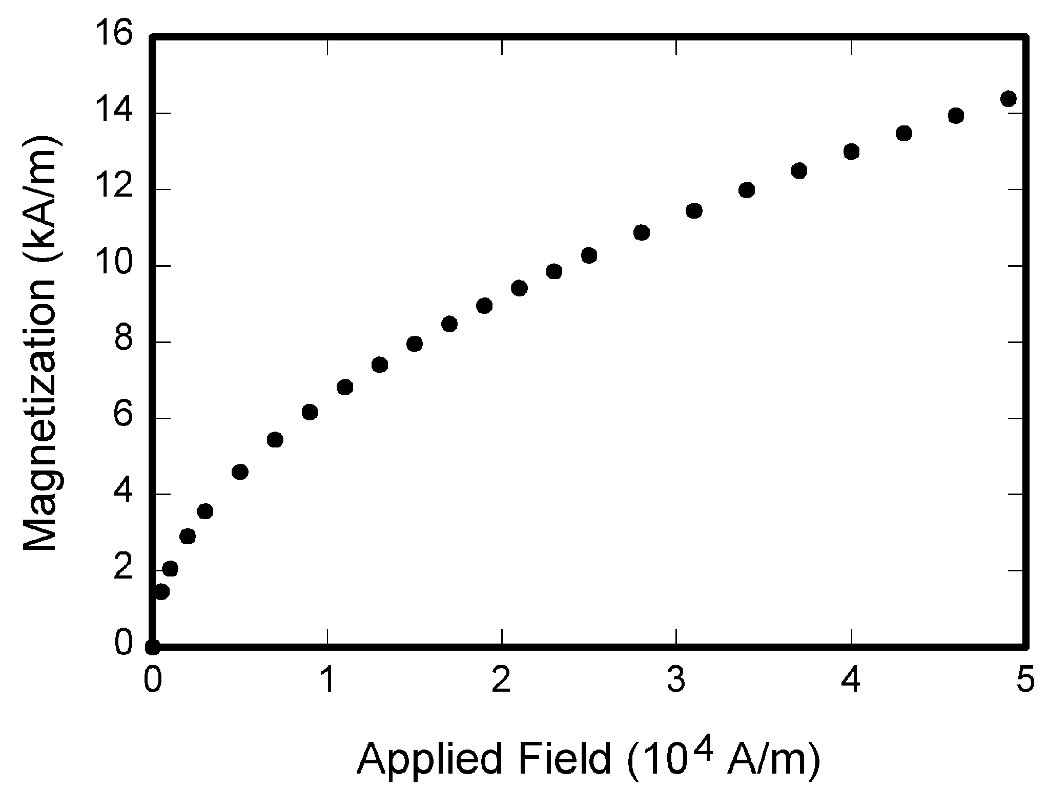

Fig. 1. Magnetization as a function of applied field. Note that “Fig.” is abbreviated. There is a period after the figure number, followed by one space. It is good practice to briefly explain the significance of the figure in the caption.

Figure axis labels are often a source of confusion. Use words rather than symbols. As an example, write the quantity “Magnetization,” or “Magnetization *M*,” not just “*M*.” Put units in parentheses. Do not label axes only with units. As in Fig. 1, for example, write “Magnetization (A/m)” or “Magnetization (Am−1),” not just “A/m.” Do not label axes with a ratio of quantities and units. For example, write “Temperature (K),” not “Temperature/K.” Table 1 shows some examples of units of measure.

Multipliers can be especially confusing. Write “Magnetization (kA/m)” or “Magnetization (103 A/m).” Do not write “Magnetization (A/m) × 1,000” because the reader would not know whether the top axis label in Fig. 1 meant 16,000 A/m or 0.016 A/m. Figure labels should be legible, approximately 8 to 12 point type. When creating your graphics, especially in complex graphs and charts, please ensure that line weights are thick enough that when

reproduced at print size, they will still be legible. We suggest at least 1 point.

## 6.3 Footnotes

Number footnotes separately in superscripts (Insert | Footnote)[1]. Place the actual footnote at the bottom of the column in which it is cited; do not put footnotes in the reference list (endnotes). Use letters for table footnotes (see Table 1). Please do not include footnotes in the abstract and avoid using a footnote in the first column of the article. This will cause it to appear above the affiliation box, making the layout look confusing.

TABLE 1  
Units for Magnetic Properties

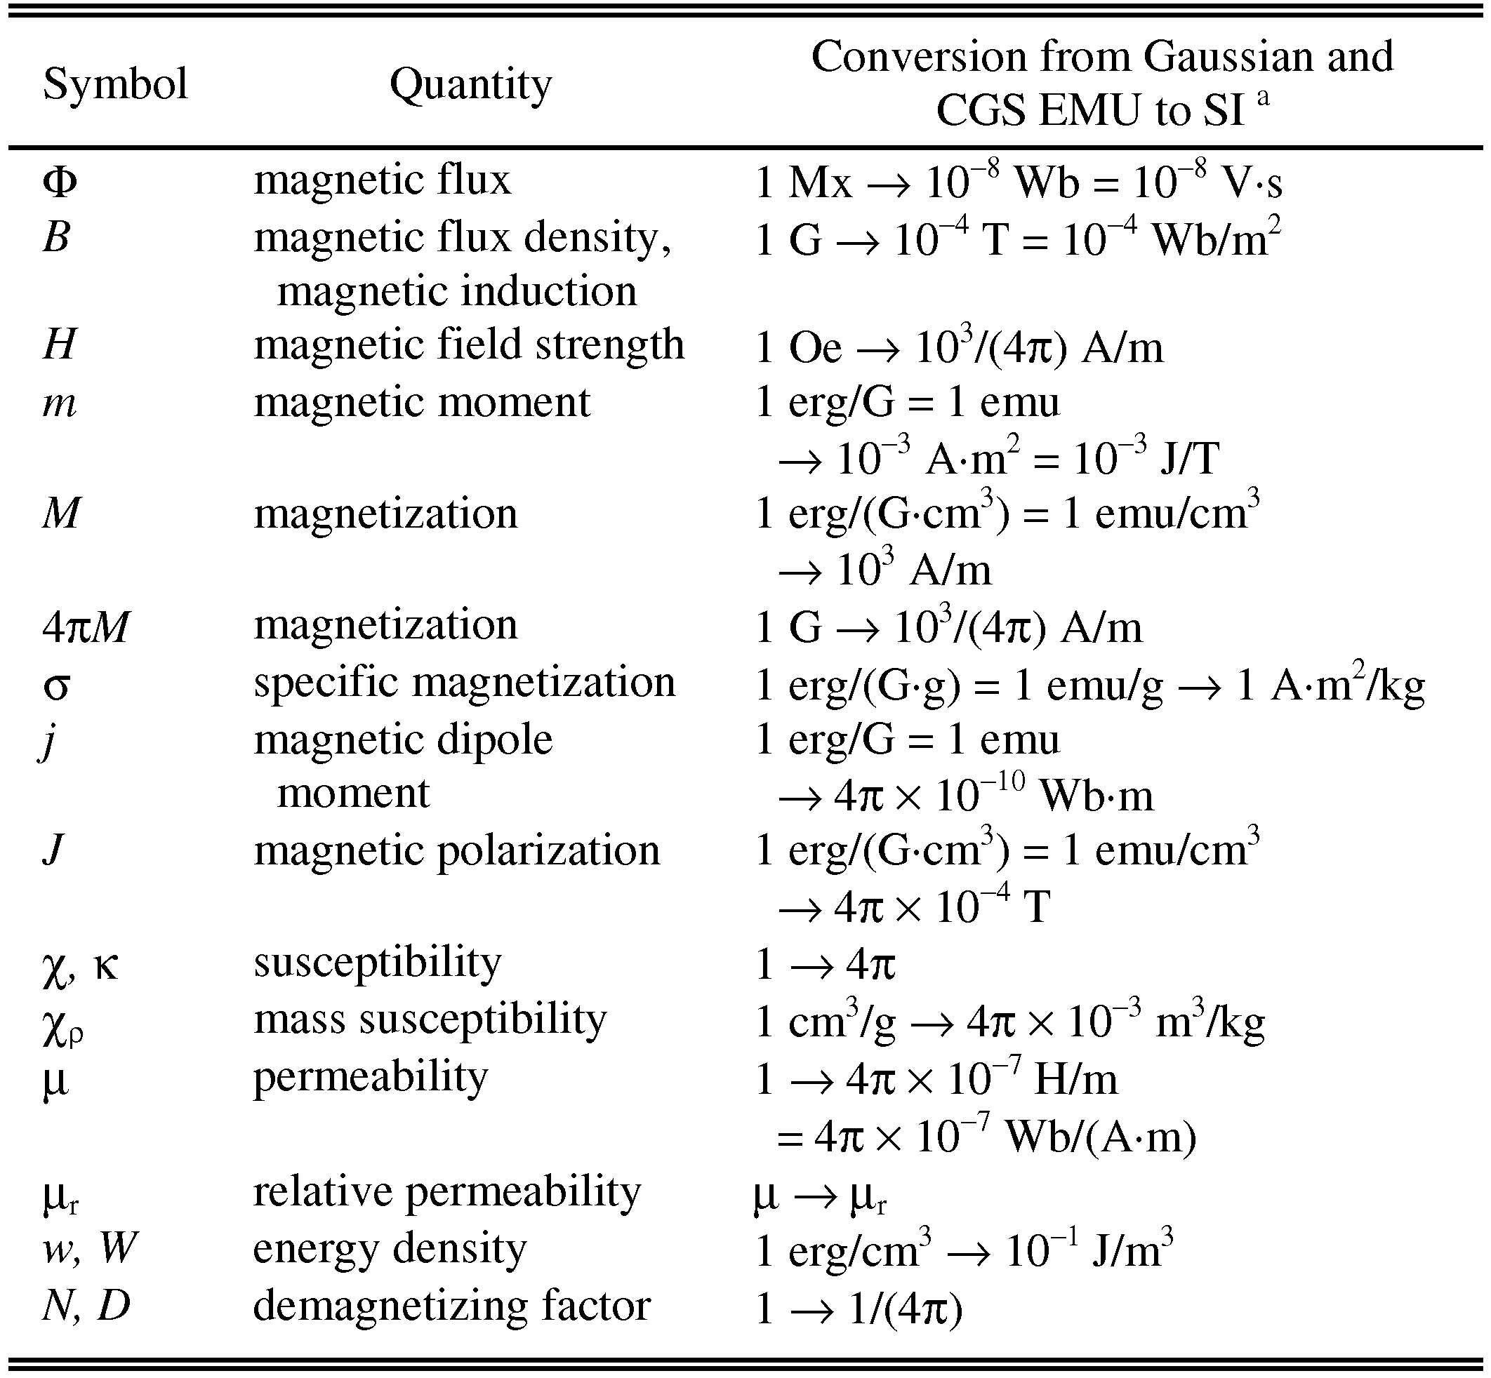

Statements that serve as captions for the entire table do not need footnote letters.

aGaussian units are the same as cgs emu for magnetostatics; Mx = maxwell, G = gauss, Oe = oersted; Wb = weber, V = volt, s = second, T = tesla, m = meter, A = ampere, J = joule, kg = kilogram, H = henry.

## 6.4 Lists

The IEEE Computer Society style is to create displayed lists if the number of items in the list is longer than three. For example, within the text lists would appear 1) using a number, 2) followed by a close parenthesis. However, longer lists will be formatted so that:

1. Items will be set outside of the paragraphs.
2. Items will be punctuated as sentences where it is appropriate.
3. Items will be numbered, followed by a period.

## 6.5 Theorems and Proofs

Theorems and related structures, such as axioms corollaries, and lemmas, are formatted using a hanging indent paragraph. They begin with a title and are followed by the text, in italics.

**Theorem 1.** *Theorems, corollaries, lemmas, and related structures follow this format. They do not need to be numbered, but are generally numbered sequentially.*

Proofs are formatted using the same hanging indent format. However, they are not italicized.

**Proof.** The same format should be used for structures such as remarks, examples, and solutions (though these would not have a Q.E.D. box at the end as a proof does). □

# 7 End Sections

## Appendices

Appendices, if present, appear online as supplemental material. In the event multiple appendices are required, they will be labeled “Appendix A,” “Appendix B, “ etc.

IEEE Computer Society Transactions accepts supplemental materials for review with regular paper submissions. These materials may be published on our Digital Library with the electronic version of the paper and are available for free to Digital Library visitors. Please see our guidelines below for file specifications and information. Any submitted materials that do not follow these specifications will not be accepted. All materials must follow US copyright guidelines and may not include material previously copyrighted by another author, organization or company. More information can be found at <http://www.computer.org/portal/web/peerreviewjournals/author#supplemental>.

## 7.2 Acknowledgments

The preferred spelling of the word “acknowledgment” in American English is without an “e” after the “g.” Use the singular heading even if you have many acknowledgments. Avoid expressions such as “One of us (S.B.A.) would like to thank ... .” Instead, write “F. A. Author thanks ... .” Sponsor and financial support acknowledgments are included in the acknowledgment section. For example: This work was supported in part by the US Department of Commerce under Grant BS123456 (sponsor and financial support acknowledgment goes here). Researchers that contributed information or assistance to the article should also be acknowledged in this section. Also, if corresponding authorship is noted in your paper it will be placed in the acknowledgment section. Note that the acknowledgment section is placed at the end of the paper before the reference section.

## 7.3 References

Unfortunately, the Computer Society document translator cannot handle automatic endnotes in Word; therefore, type the reference list at the end of the paper using the “References” style. See the IEEE Computer Society’s style for reference formatting at: <http://www.computer.org/portal/web/publications/style_refs>. The order in which the references are submitted in the manuscript is the order they will appear in the final paper, i.e., references submitted nonalphabetized will remain that way.

Please note that the references at the end of this document are in the preferred referencing style. Within the text, use “et al.” when referencing a source with more than three authors. In the reference section, give all authors’ names; do not use “et al.” Do not place a space between an authors' initials. Papers that have not been published should be cited as “unpublished” [4]. Papers that have been submitted or accepted for publication should be cited as “submitted for publication” [5]. Please give affiliations and addresses for personal communications [6].

Capitalize all the words in a paper title. For papers published in journals not published in English, please give the English citation first, followed by the original foreign-language citation [7].

## 7.4 Additional Formatting and Style Resources

Additional information on formatting and style issues can be obtained in the IEEE Computer Society Style Guide, which is posted online at: <http://www.computer.org/portal/web/publications/styleguide>. Click on the appropriate topic under the Special Sections link.

# Conclusion

Although a conclusion may review the main points of the paper, do not replicate the abstract as the conclusion. A conclusion might elaborate on the importance of the work or suggest applications and extensions. Authors are strongly encouraged not to reference multiple figures or tables in the conclusion—these should be referenced in the body of the paper.

**Acknowledgment**

The authors wish to thank A, B, C. This work was supported in part by a grant from XYZ.

**References**

[1] D. Choi, C. J. Shallue, Z. Nado, J. Lee, C. J. Maddison, and G. E. Dahl, “On empirical comparisons of optimizers for deep learning,” *arXiv Prepr. arXiv1910.05446*, 2019.

[2] D. Soydaner, “A Comparison of Optimization Algorithms for Deep Learning,” *Int. J. Pattern Recognit. Artif. Intell.*, p. 2052013, 2020.

[3] A. C. Wilson, R. Roelofs, M. Stern, N. Srebro, and B. Recht, “The marginal value of adaptive gradient methods in machine learning,” in *Advances in neural information processing systems*, 2017, pp. 4148–4158.

[4] F. Schneider, L. Balles, and P. Hennig, “DeepOBS: A deep learning optimizer benchmark suite,” *arXiv Prepr. arXiv1903.05499*, 2019.

[5] H. Robbins and S. Monro, “A stochastic approximation method,” *Ann. Math. Stat.*, pp. 400–407, 1951.

[6] G. Hinton, N. Srivastava, and K. Swersky, “Neural networks for machine learning,” *Coursera, video Lect.*, vol. 264, no. 1, 2012.

[7] D. P. Kingma and J. Ba, “Adam: A method for stochastic optimization,” *arXiv Prepr. arXiv1412.6980*, 2014.

[8] B. T. Polyak, “Some methods of speeding up the convergence of iteration methods,” *USSR Comput. Math. Math. Phys.*, vol. 4, no. 5, pp. 1–17, 1964.

[9] J. Duchi, E. Hazan, and Y. Singer, “Adaptive subgradient methods for online learning and stochastic optimization.,” *J. Mach. Learn. Res.*, vol. 12, no. 7, 2011.

[10] M. D. Zeiler, “Adadelta: an adaptive learning rate method,” *arXiv Prepr. arXiv1212.5701*, 2012.

[11] I. Sutskever, J. Martens, G. Dahl, and G. Hinton, “On the importance of initialization and momentum in deep learning,” in *International conference on machine learning*, 2013, pp. 1139–1147.

[12] T. Dozat, “Incorporating nesterov momentum into adam,” 2016.

[13] J. R. Sashank, K. Satyen, and K. Sanjiv, “On the convergence of adam and beyond,” 2018.

1. J.S. Bridle, “Probabilistic Interpretation of Feedforward Classification Network Outputs, with Relationships to Statistical Pattern Recognition,” *Neurocomputing—Algorithms, Architectures and Applications,* F. Fogelman-Soulie and J. Herault, eds., NATO ASI Series F68, Berlin: Springer-Verlag, pp. 227-236, 1989. (Book style with paper title and editor)
2. W.-K. Chen, *Linear Networks and Systems.* Belmont, Calif.: Wadsworth, pp. 123-135, 1993. (Book style)
3. H. Poor, “A Hypertext History of Multiuser Dimensions,” *MUD History,* http://www.ccs.neu.edu/home/pb/mud-history.html. 1986. (URL link *include year)
4. K. Elissa, “An Overview of Decision Theory,"unpublished. (Unpublished manuscript)
5. R. Nicole, "The Last Word on Decision Theory," *J. Computer Vision,* submitted for publication. (Pending publication)
6. C. J. Kaufman, Rocky Mountain Research Laboratories, Boulder, Colo., personal communication, 1992. (Personal communication)
7. D.S. Coming and O.G. Staadt, "Velocity-Aligned Discrete Oriented Polytopes for Dynamic Collision Detection," *IEEE Trans. Visualization and Computer Graphics*, vol. 14,  no. 1,  pp. 1-12,  Jan/Feb  2008, doi:10.1109/TVCG.2007.70405. (IEEE Transactions )
8. S.P. Bingulac, “On the Compatibility of Adaptive Controllers,” *Proc. Fourth Ann. Allerton Conf. Circuits and Systems Theory*, pp. 8-16, 1994. (Conference proceedings)
9. H. Goto, Y. Hasegawa, and M. Tanaka, “Efficient Scheduling Focusing on the Duality of MPL Representation,” *Proc. IEEE Symp. Computational Intelligence in Scheduling* *(SCIS ’07)*, pp. 57-64, Apr. 2007, doi:10.1109/SCIS.2007.367670. (Conference proceedings)
10. J. Williams, “Narrow-Band Analyzer,” PhD dissertation, Dept. of Electrical Eng., Harvard Univ., Cambridge, Mass., 1993. (Thesis or dissertation)
11. E.E. Reber, R.L. Michell, and C.J. Carter, “Oxygen Absorption in the Earth’s Atmosphere,” Technical Report TR-0200 (420-46)-3, Aerospace Corp., Los Angeles, Calif., Nov. 1988. (Technical report with report number)
12. L. Hubert and P. Arabie, “Comparing Partitions,” *J. Classification,* vol. 2, no. 4, pp. 193-218, Apr. 1985. (Journal or magazine citation)
13. R.J. Vidmar, “On the Use of Atmospheric Plasmas as Electromagnetic Reflectors,” *IEEE Trans. Plasma Science*, vol. 21, no. 3, pp. 876-880, available at http://www.halcyon.com/pub/journals/21ps03-vidmar, Aug. 1992. (URL for Transaction, journal, or magzine)
14. J.M.P. Martinez, R.B. Llavori, M.J.A. Cabo, and T.B. Pedersen, "Integrating Data Warehouses with Web Data: A Survey," *IEEE Trans. Knowledge and Data Eng.*, preprint, 21 Dec. 2007, doi:10.1109/TKDE.2007.190746.(PrePrint)

**First A. Author** Allbiographies should be limited to one paragraph consisting of the following: sequentially ordered list of degrees, including years achieved; sequentially ordered places of employ concluding with current employment; association with any official journals or conferences; major professional and/or academic achievements, i.e., best paper awards, research grants, etc.; any publication information (number of papers and titles of books published); current research interests; association with any professional associations. Author membership information, e.g., is a member of the IEEE and the IEEE Computer Society, if applicable, is noted at the end of the biography.

**Second B. Author Jr.** biography appears here.

**Third C. Author** biography appears here.

1. It is recommended that footnotes be avoided (except for the unnumbered footnote with the receipt date on the first page). Instead, try to integrate the footnote information into the text.